Contents

1. Prepare the sort code file 1
2. Upload new bank sort codes 4
3. Check upload data in the Back-Office 6

Prepare the sort code file

- When new bank sorting codes become available, we will receive an email notification, which is logged in HEAT as an incident. Click the link in the incident record to go to: www.sortingcodeselectronic.co.uk
- On the login screen, enter username “unioxford6” and password “bridge”.
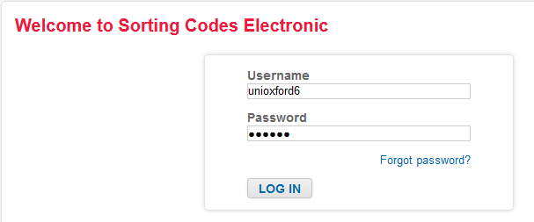
- On the next page click the option for “Variable Length – delimited” to download the appropriate file.
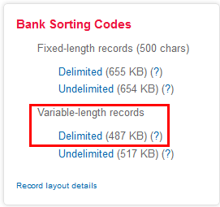

- Save the file to the Bank Sort Codes folder, at:
P:\PROJECTS\HRIS Programme\12. Support\Reference Data\Bank Sort Codes

- Once you’ve saved the file, go to the folder, unzip the file and save the extract as codes.dat (same folder).

- Now go to Discoverer and run the "PERSUP09_Bank Sort Codes Reference Data" report.
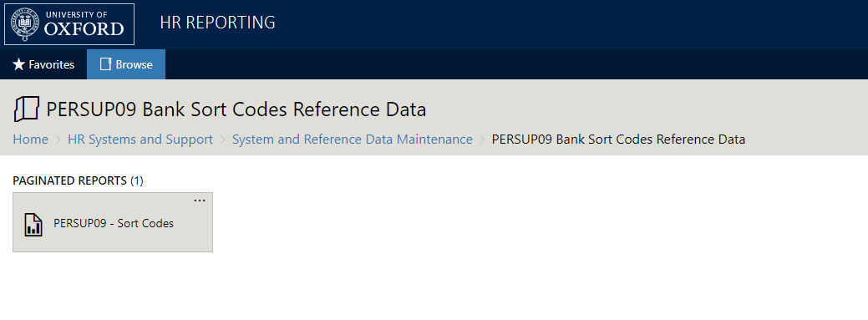

Export the report to Excel.
- From the Bank Sort Codes folder, open the SORT CODE MASTER.xlsm file. Copy & paste the output from your Discoverer report into the "CTR_Bank Sort Codes Export" tab of the SORT CODE MASTER file.
- In the “Instructions” tab, click the “Run comparison” arrow. This will run a macro which compares the existing sort codes from your Discoverer report to the new sort code in the codes.dat file.
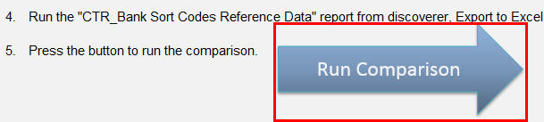

- The macro will export all the codes, any changes to existing reference data and any new sort codes into a new file. Save this file as Sort Code Export [dd mm yy].xlsx in the Bank Sort Codes folder.
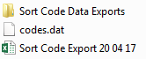
- Open the file and go to the “New” tab.

- Copy & paste the data from this tab into a new file and click “Save As…”. When prompted, save the file in .CSV format, with the name NEW Sort Codes [dd mm yy].
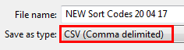

Excel will ask if you want to use the .CSV format; click “Yes”.

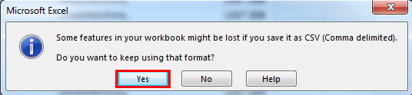

- Now close the file. Before the file shuts, Excel will ask you if you want to save your changes. It’s essential to click “Don’t Save” here, as this ensures your file will remain in the correct format for upload.

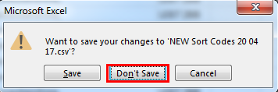
- Go to Notepad++ and click Open… Search for your newly-created .CSV file and open it within the Notepad++ application.

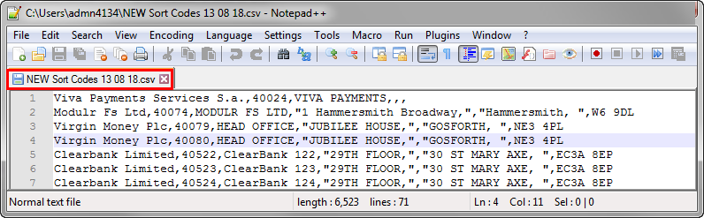
- You will see quotation marks within the data. These must be removed from the file before you can upload it into Core.

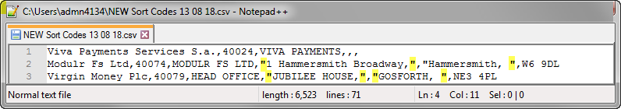

Enter “CTRL + F” and do a Find & Replace to delete all the quotation marks, replacing (“) with nothing ():

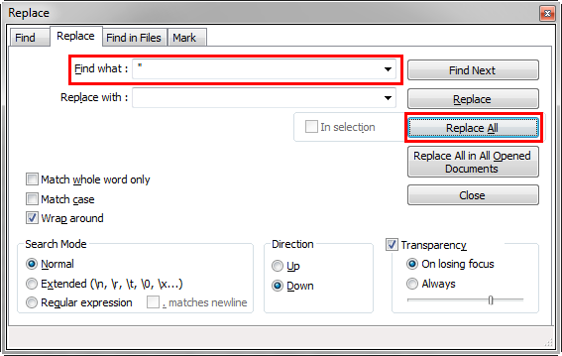

The file will refresh itself and a message will appear confirming the quotation marks have been replaced:

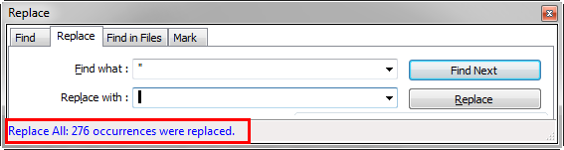

- You will also notice instances of multiple commas in a row within the data. These must be deleted from the file before you can upload it into Core. Enter “CTRL + F” again and replace all instances of multiple commas with single commas, e.g. replace “, ,” with “,”.

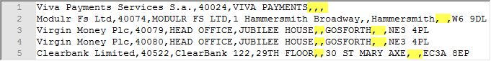

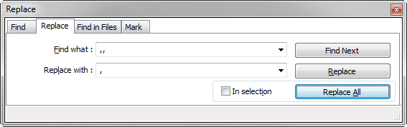

Once again, the file will refresh itself and a message will appear confirming that the excess commas have been replaced:

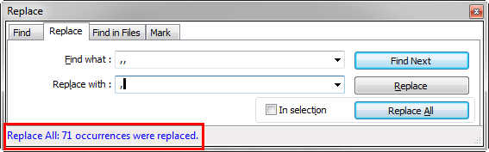

Save the file and exit Notepad++.

- Now open the file again in Excel and check that the data does not extend beyond Column F. (The changes you made in Notepad++ may have pushed some cells to the right.)

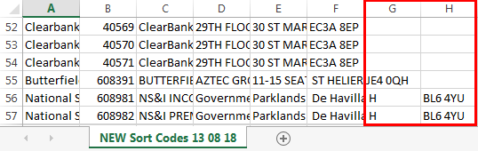

If there is data in cells beyond Column F, you will need to move that data to the left so that each line only has data in Columns A – F:

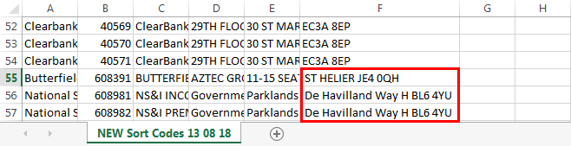

Save your changes. Excel will ask if you want to use the .CSV format; click “Yes”.



Now close the file. Before the file shuts, Excel will ask you if you want to save your changes. It’s essential to click “Don’t Save” here, as this ensures your file will remain in the correct format for upload.

The file is now ready for upload.

Upload new bank sort codes
Navigate to: CorePortal > Administrator Dashboard > Data Migration

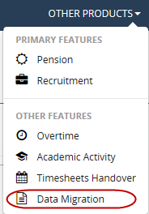

- Now go to the Upload tab in the left-hand menu. Scroll to “F: Reference level” and select “Bank Reference”.
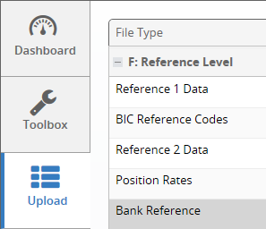

- Click the settings button on the right side of the line and select “Upload”. Browse for your file and click “Upload” after you have selected it.

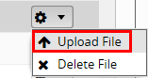
A message will appear.

 | The system will upload your file and validate the data within it to see if it is ready to be migrated into Core. The data validation process runs every 10 minutes, and may take several minutes depending on the size of your file, so you may need to wait before moving on to the next step.

You can check the status of your file on the Upload screen.

- When your file has been validated, you will get a confirmation message in the status field. This message will vary depending on whether your file has passed the validation checks.
  - File has errors:
  - File ready for migration:

If the system encountered errors while validating your data, go to the Errors tab. The number of errors will be displayed at the top of the screen.

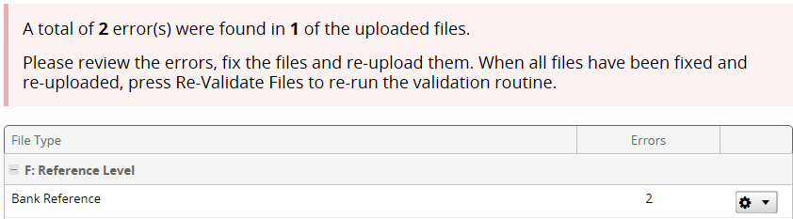

Select “View All Errors” to review them.

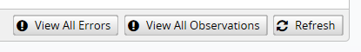

 | Note: You will need to fix all errors and re-validate your file before you can migrate your data into Core.

- If the system has not hit any errors, you can go straight to migrating your data. To do this, go to the Migrate tab. Your validated file should appear in the window. Click “Migrate” to migrate the data into Core. This process may take several minutes.
- Once your data has successfully migrated into Core, a line will appear in the Completed tab specifying the type of data you have migrated and when the migration happened.

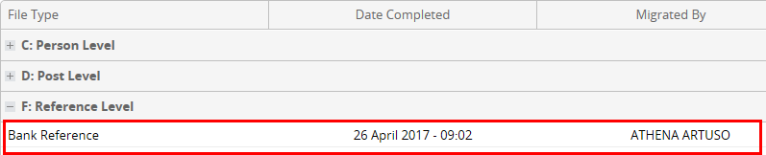

You should now log in to the Core Back-Office and check whether your data is appearing correctly within Core.

Check upload data in the Back-Office
Navigate to: CorePersonnel > Reference > A-C > Bank Sort Codes

- When you navigate to the path above, you will be taken to the “Maintain Bank Details” screen, where the first bank in the reference library will appear.
- Do a sense-check for some of the banks included in your upload file by clicking the Query Mode button:

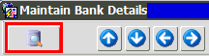
- If the details displayed match the details in your NEW Sort Codes [dd mm yy] upload file, the migration has been successful.

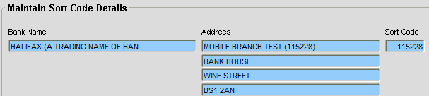

Knowledge Article: P:\PROJECTS\HRIS Programme\12. Support\Change Control\Change Management Knowledge Documents\Bank Sort Codes Knowledge Article.docx

